2023-CSE5BDC-T5-W - Big Data Management on the Cloud

Big Data Management on the Cloud Week 1. NOTES

What does cloud computing mean to you? How would you explain it to someone who is not familiar with the concept?

Cloud computing is a service which provides software and hardware remotely in order to make a user’s life simpler.

Cloud computing is enabled by increasingly efficient and reliable internet.

Activity: Check your understanding 1

More control over IT resources ------> Less control over IT resources

In descending order

-IaaS: Infrastructure as a service

-PaaS: Platform as a service

-SaaS: Software as a service

Quiz: Check your understanding 2

Which of the following is not an advantage of using cloud computing?

-Increase speed and agility

-Fixed monthtly billing (Correct)

-Global access

-Scaling on demand

Which two of the following are not benefits of using AWS cloud computing?

-Multiple procurement cycles (Correct)

-High latency (Correct)

True or false? AWS owns and maintains the network-connected hardware required for application services, while you provision and use what you need.

Answer: True

**ACTIVITY: Lab 1 AWS Academy Lab**

**Module 1-Cloud Concepts Overview**

**LAB 1.**

1. Follow the instructions in your invitation email for the AWS Academy Cloud Foundations Course to log into the AWS Academy LMS page.
2. In the Introduction section of the AWS Academy LMS page, read the *How to complete Lab exercises* instructions. (See on LMS)

**Section 1. Introduction to cloud computing.**

Infrastructure as software

-Cloud computing enables you to stop thinking of your infrastructure as hardware, and instead think of (and use) it as software.

Traditional computing model.

Infrastructure as hardware.

Hardware solutions:

-Require space, staff, physical security, planning, capital expenditure.

-Have a long hardware procurement cycle.

-Require you to provision capacity by guessing theoretical maximum peaks.

Cloud computing model.

Infrastructure as software.

Software solutions:

-Are flexible

-Can change more quickly, easily, and cost-effectively than hardware solutions.

-Eliminate the undifferentiated heavy-lifting tasks.

Cloud computing deployment models

-Cloud

-Hybrid

-On-premises (private cloud)

**Section 2. Advantages of the Cloud**

Trade captial expense for variable expense.

-Data center investment based on forecast

-Pay only for the amount you consume (PAYG: Pay as you go)

Massive economies of scale.

-Because of aggregate usage from all customers, AWS can achieve higher economies of scale

and pass savings on to customers.

Stop guessing capacity.

-Overestimated server capacity

-Underestimated server capacity

-Scaling on demand

Increase speed and agility.

-Weeks between wanting resources and having resources.

-Minutes between wanting resources and having resources.

Stop spending money on running and maintaining data centers.

-Running data centers

<---> (Investment)

-Business and customers

Go global in minutes.

**Section 3.**

**Introduction to AWS (Amazon Web Services)**

What are web services? A web service is any piece of software that makes itself avaiable over the internet and uses a standardized format - such as Extensible Markup Language (XML) or JavaScript Object Notation (JSON)-for the request and the response of an application programming interface (API) interaction.

Client ------------------------- ((Internet))--------(Request message)-----> Web-service

<---(Response message)----- -------------------------------

**What is AWS?**

-AWS is a secure cloud platform that offers a broad set of global cloud-based products.

-AWS provides you with on-demand access to compute, storage, network, database, and other

IT resources and management tools.

-AWS offers flexibility

-You can pay only for the individual services you nedd, for as long as you use them.

-AWS Services work together like building blocks.

Services covered in this course,

Compute services

-Amazon EC2

-AWS Lambda

-AWS Elastic Beanstalk

-Amazon EC2 Auto Scaling

-Amazon ECS

-Amazon EKS

-Amazon ECR

-AWS Fargate

Storage services-

-Amazon S3

-Amazon S3 Glacier

-Amazon EFS

-Amazon EBS

Database services-

-Amazon RDS

-Amazon DynanmoDB

-Amazon Redshift

-Amazon Aurora

Security, Identity, and Compliance services

-AWS IAM

-Amazon Cognito

-AWS Shield

-AWS Artifact

-AWS KMS

Networking and Content Delivery services

-Amazon VPC

-Amazon Route S3

-Amazon CloudFron

-Elastic Load Balancing

Management and Governance services

-AWS Trusted Advisor

-AWS CloudWatch

-AWS CloudTrail

-AWS Well-Architected Tool

-AWS Auto Scaling

-AWS Command Line Interface

-AWS Config

-AWS Management Console

-AWS Organizations

AWS Cost Management services

-AWS Cost and Usage Report

-AWS Budgets

-AWS Cost Explorer

Three ways to interact with AWS

-AWS Management Console

Easy-to-use graphical interface.

-Command Line Interface (AWS CLI)

Access to services by discrete commands or scripts

-Software Development Kits (SDKs)

Access services directly from your code (such as Java, Python, and others)

Section 4. Moving to the AWS Cloud.

AWS Cloud Adoption Framework (AWS CAF)

-Six core perspectives

Business

Focus on business capabilities such as IT finance, IT strategy,

benefits realization and Business risk management.

People

Focus on Human resources, staffing and people managers.

Governance

CIO, program managers, enterprise architects, business analysts, and portfolio managers.

Platform

CTO, It managers, and solutions architects.

Security

CISO, IT sercuity managers, and IT security analysts.

Operations

IT Operations managers, and IT support managers.

Focus on technical capabilities

(AWS CAF perspectives)

-AWS CAF provides guidance and best practices to help organizations build a comprehensive approach to cloud computing across the organization and throughout the IT lifecycle to accelerate successful cloud adoption.

-AWS CAF is organized into six perspectives.

-Perspectives consist of sets of capabilities.

Summary,

-Define different types of cloud computing models.

-Describe six advantages of cloud computing.

-Recognize the main AWS service categories and core services.

-Review the AWS Cloud Adoption Framework.

AWS Cert. Sample Exam question

Why is AWS more economical than traditional data centers for applications with vraiable compute workloads?

C. Amazon EC2 instances can be launched on-demand when needed.

**LAB 3 – Introduction to Amazon EC2**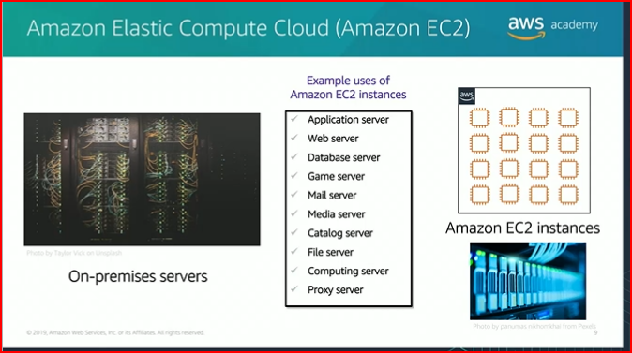

**Module 6-Compute.**

Module Overview

Topics

-Compute services overview

-Amazon EC2

-Amazon EC2 cost optimisation

-Container services

-Introduction to AWS Lambda

-Introduction to AWS Elastic Beanstalk

Activities

-Amazon EC2 versus Managed Service

-Hands-on with AWS Lambda

-Hands-on with AWS Elastic Beanstalk

Demo

-Recorded demonstration of Amazon EC2

Lab

-Introduction to Amazon EC2.

After completing this module, you should be able to:

-Provide an overview of different AWS compute services in the cloud.

-Demonstrate why to use Amazon Elastic Compute Cloud (Amazon EC2)

-Identify the functionality in the EC2 console

-Perform basic functions in Amazon EC2 to build a virtual computing environment

-Identify Amazon EC2 cost optimization elements.

-Demonstrate when to use AWS Elastic Beanstalk.

-Demonstrate when to use AWS Lambda.

-Identify how to run containerized applications in a cluster of managed servers.

**Section 1: Compute services overview.**

AWS compute services:

Amazon Web Services (AWS) offers many compute services. This module will discuss the highlighted services.

-Amazon EC2

-AWS Elastic Beanstalk

-AWS Lambda

-AWS Fargate

-Amazon Elastic Container Registry (Amazon ECR)

-Amazon Elastic Kubermetes Service (Amazon EKS)

-Amazon ELastic Container Service (Amazon ECS)

Ones not covered/will be likely in the exam.

-Amazon EC2 Auto Scaling

-AWS Outposts

-Amazon Lightsail

-AWS Services Application Repository

-VMware Cloud on AWS

-AWS Batch

**Categorizing compute services**

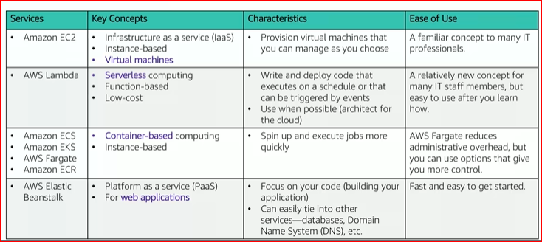

Choosing the optimal compute service

* The optimal compute service or services that you use will depend on your use case.
* Some aspects to consider –

-What is your application design?

-What are your usage patterns?

-Which configuration settings will you want to manage?

Selecting the wrong compute solution for an architecture can lead to lower performance efficiency.

-A good starting place – Understanding the available compute options.

**Module 6. Section 2 – Amazon EC2 Part 1**

Amazon Elastic Compute Cloud (Amazon EC2)

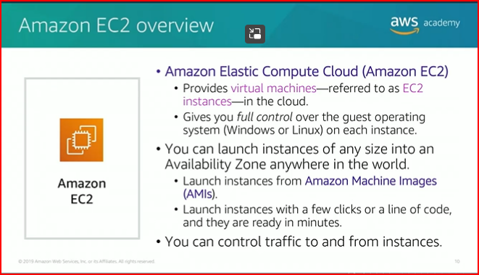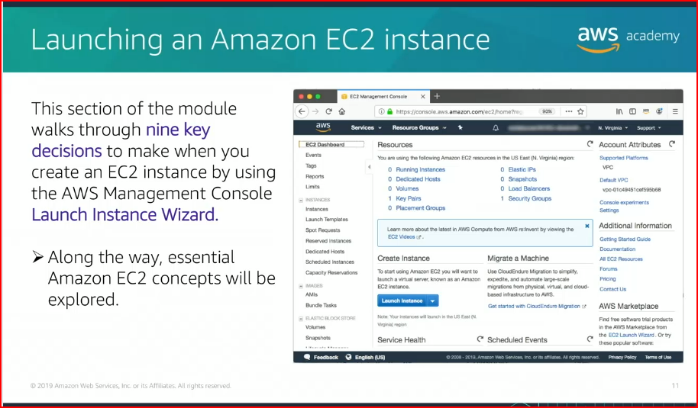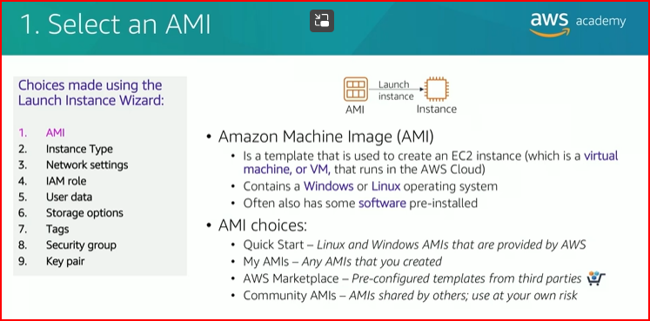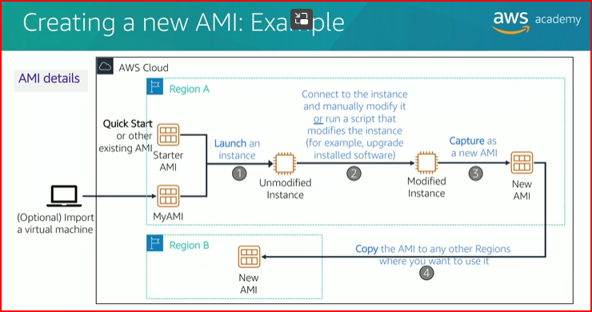

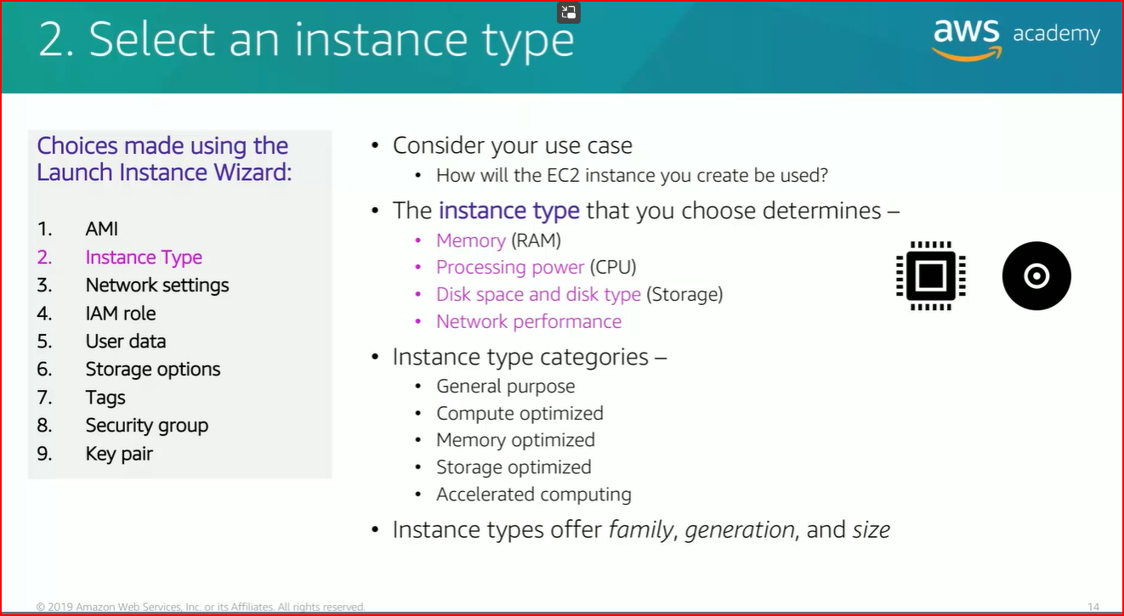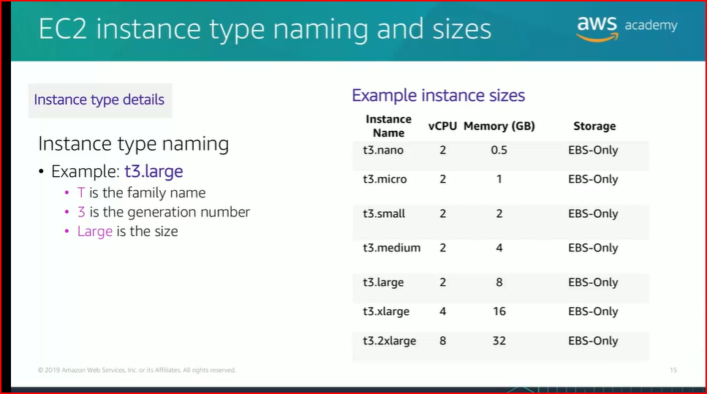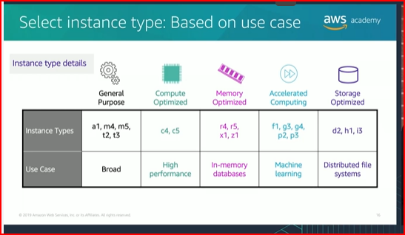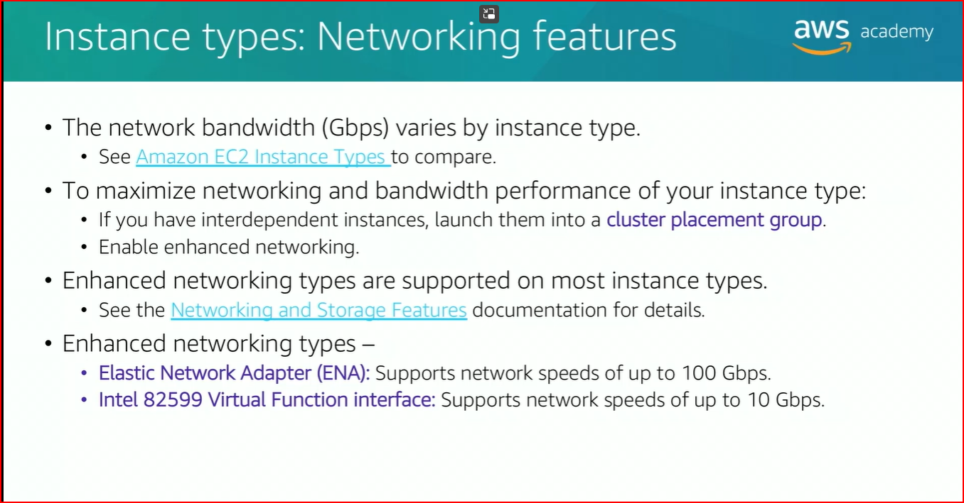

**Module 6. Section 3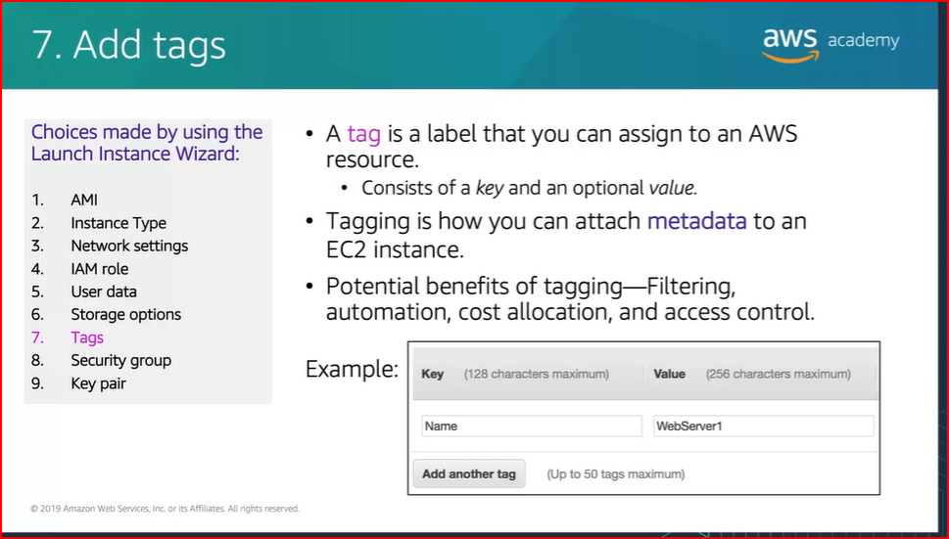 – Amazon EC2 Part 2**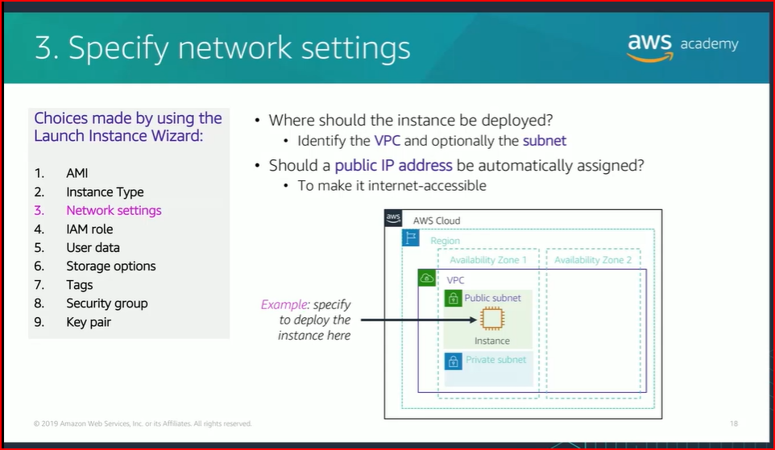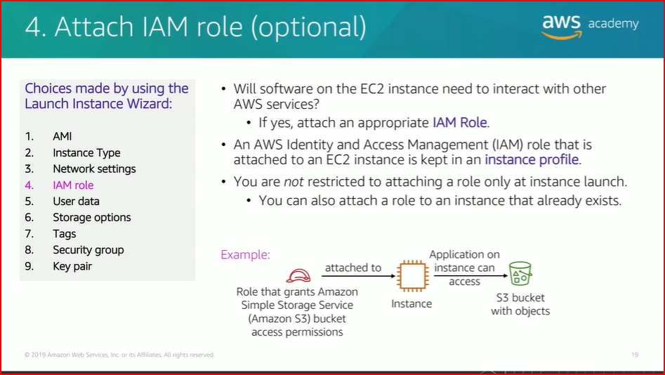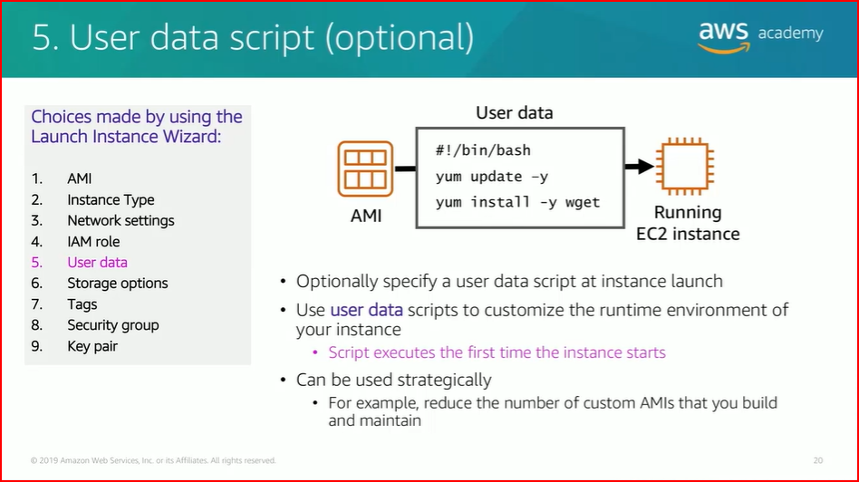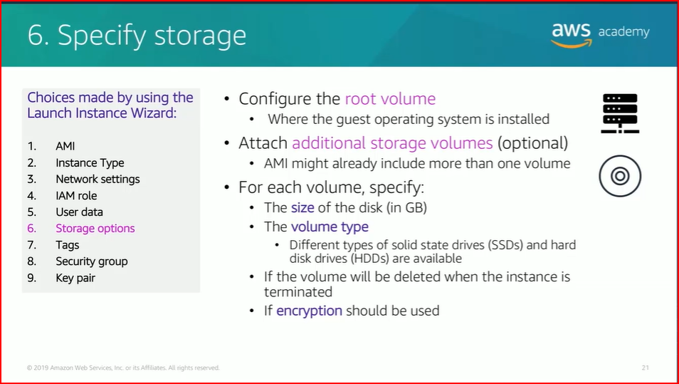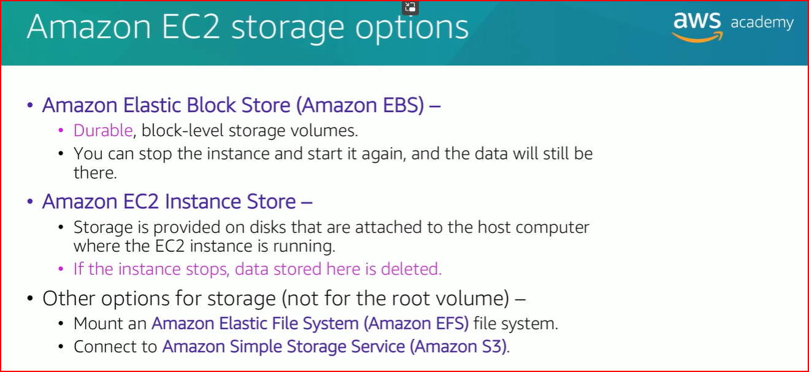

**Module 6. Section 4 – Amazon EC2 Part 3**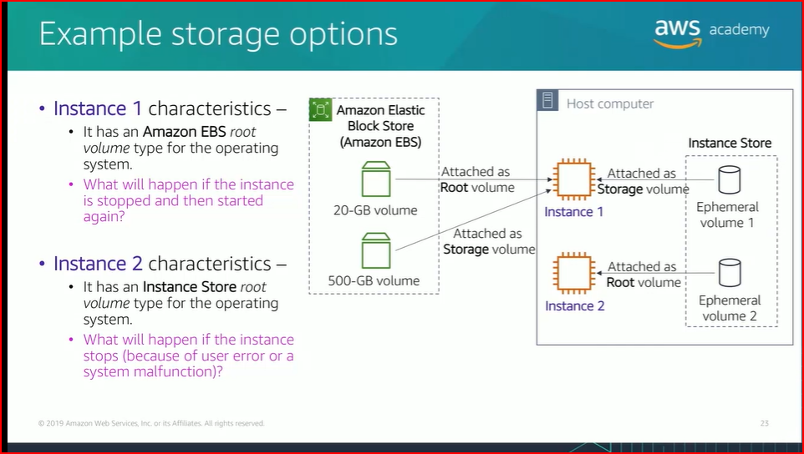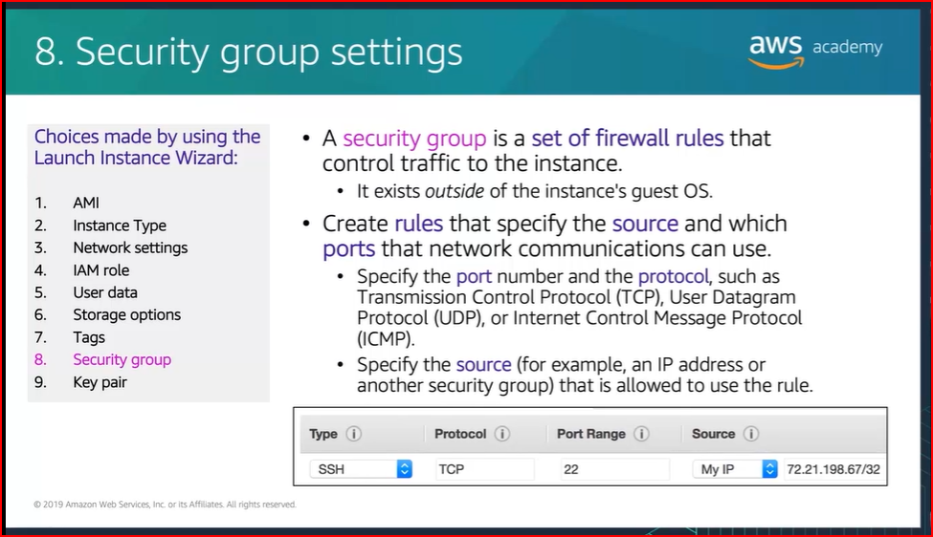

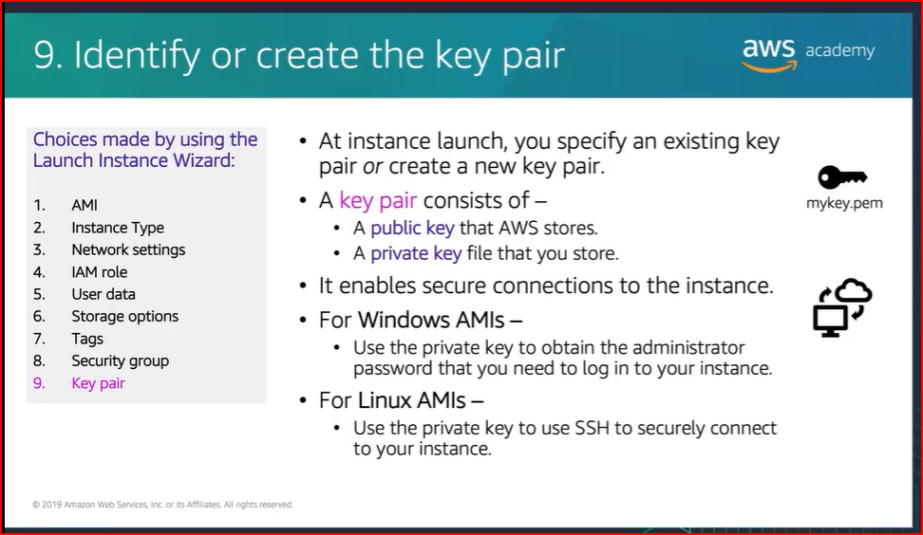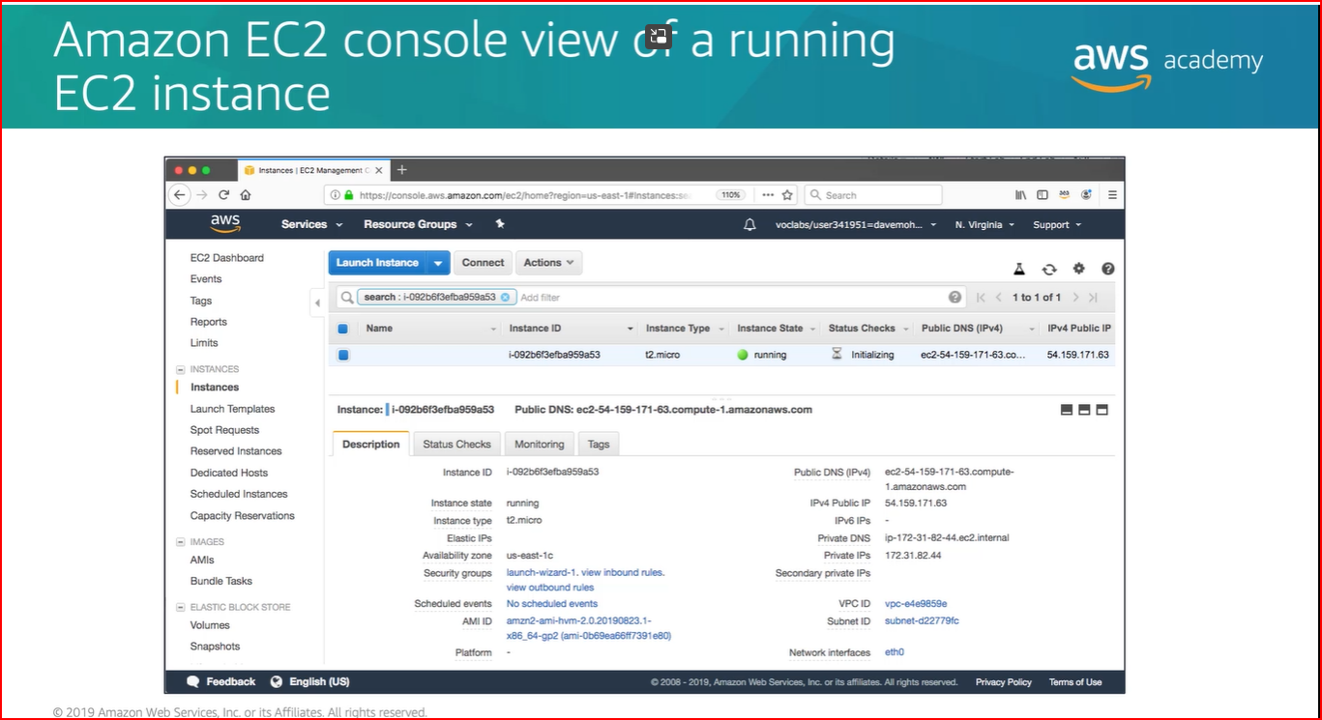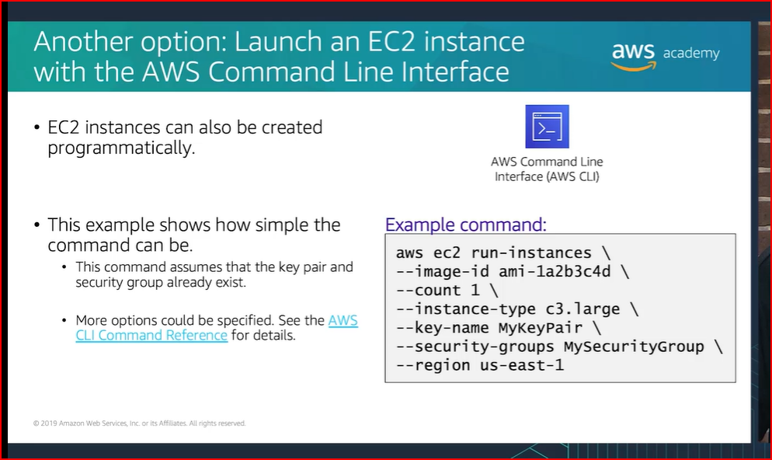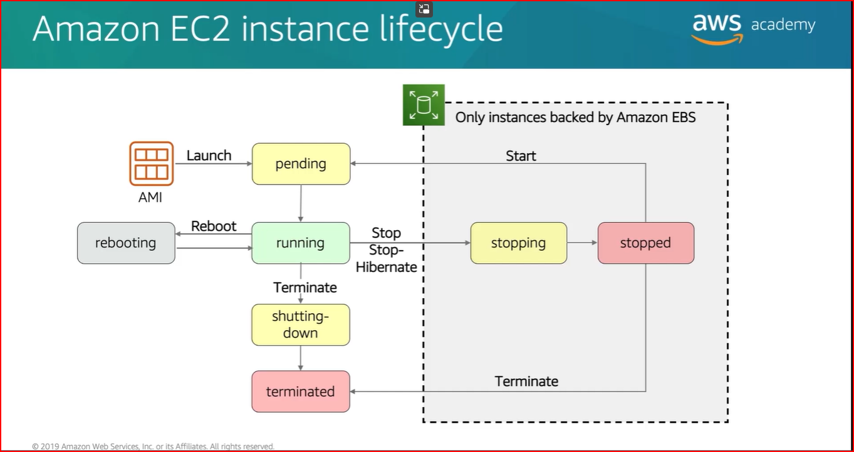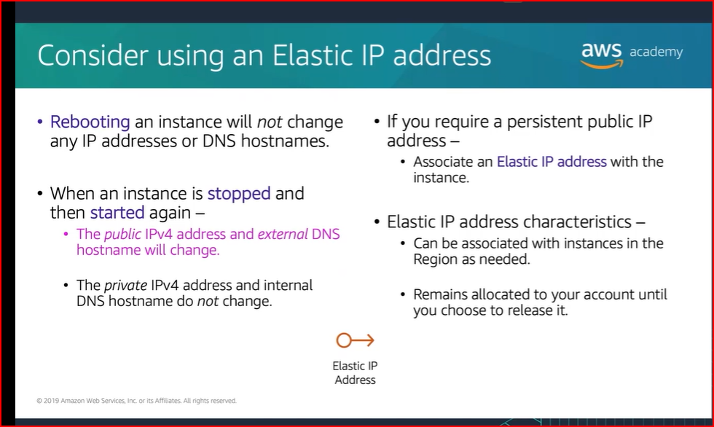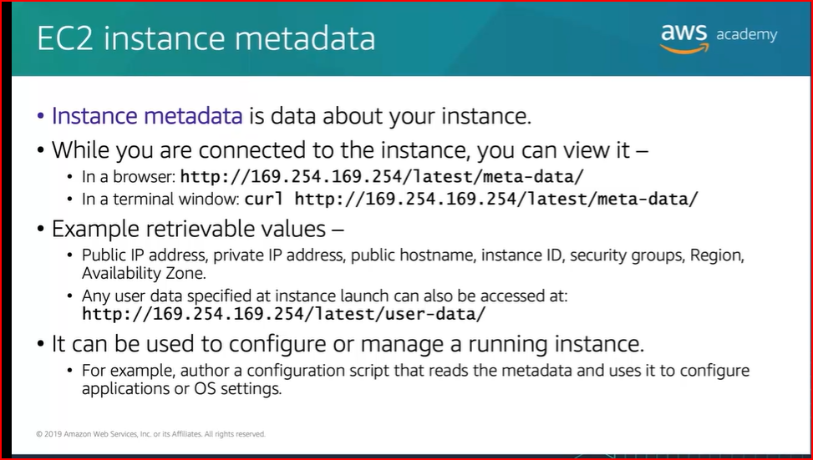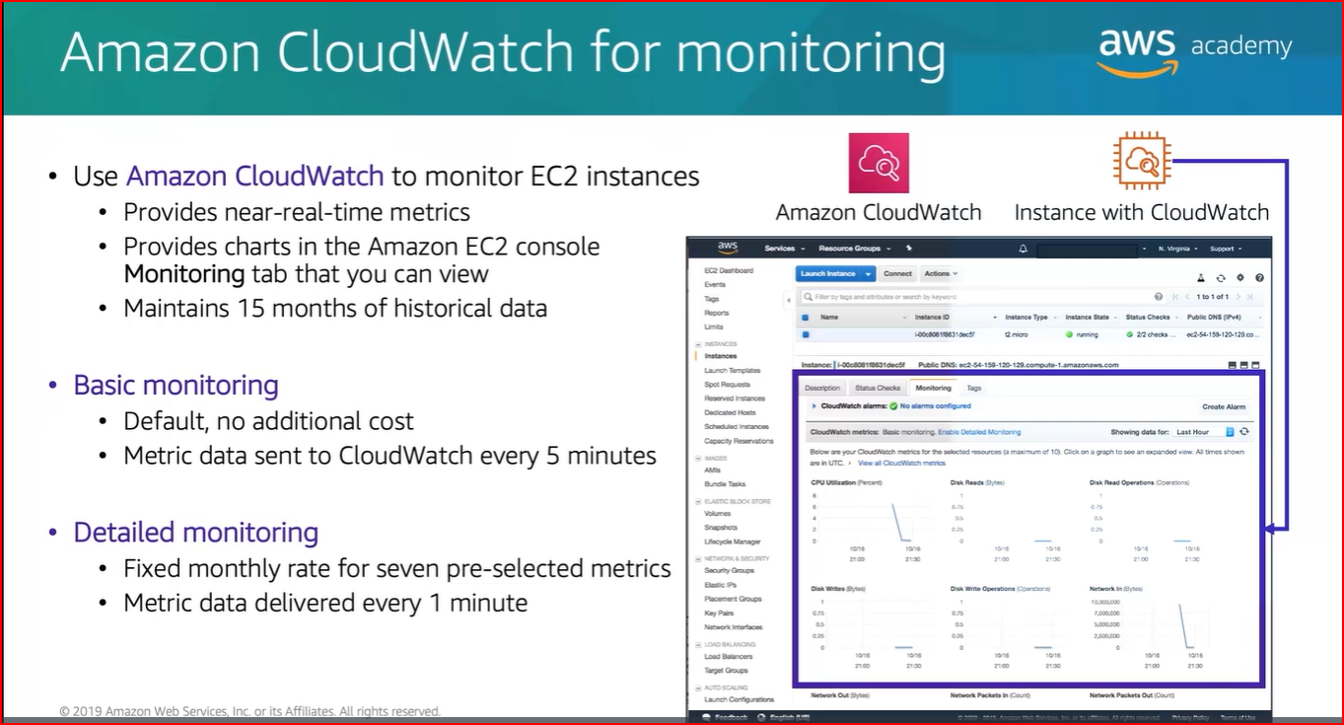

**Module 7 – Storage**

**Introduction Video**

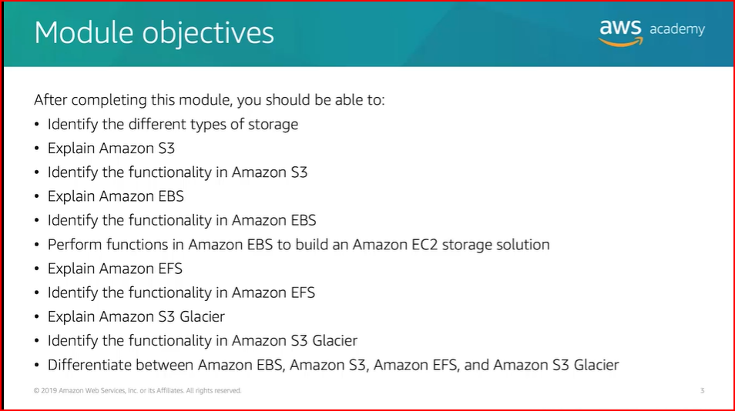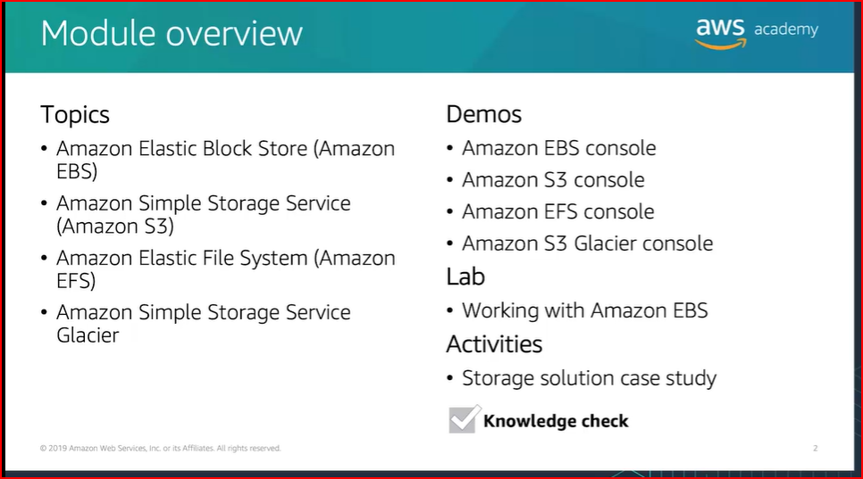

**Module 7-Section 1 Video – AWS EBS**

**Amazon Elastic Block Storage**

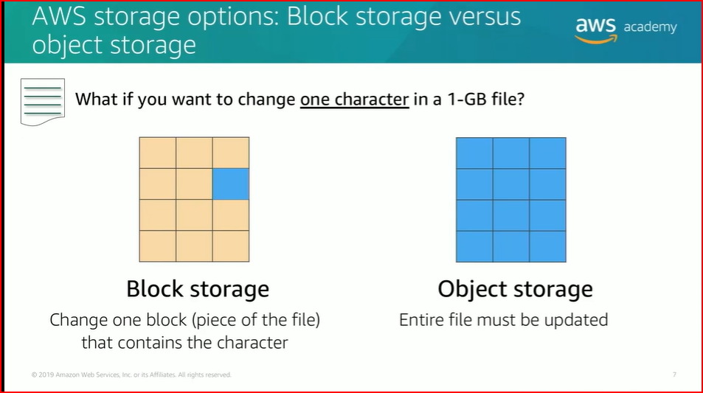

Amazon EBS enables you to create **individual storage volumes** and **attach them** to an Amazon EC2 instance.

Amazon EBS offers block-level storage.

Volumes are automatically replicated within its Availability Zone.

It can be backed up automatically to Amazon S3 through snapshots.

Uses include –

-Boot volumes and storage for Amazon Elastic Compute Cloud (Amazon EC2) instances.

-Data storage with a file system.

-Database hosts

-Enterprise applications.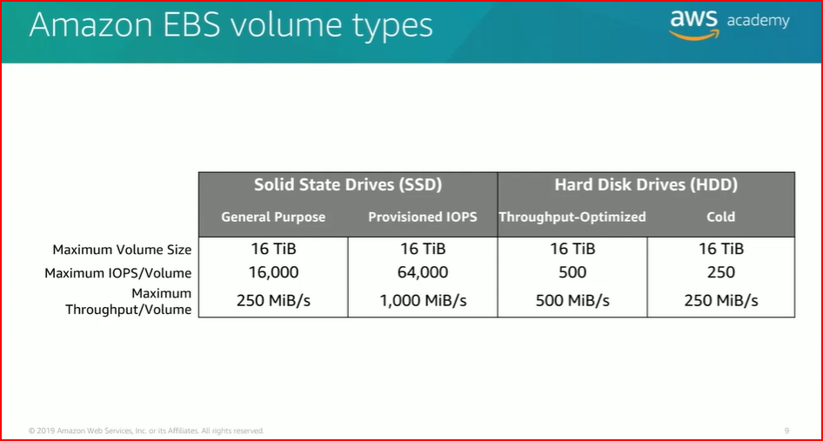 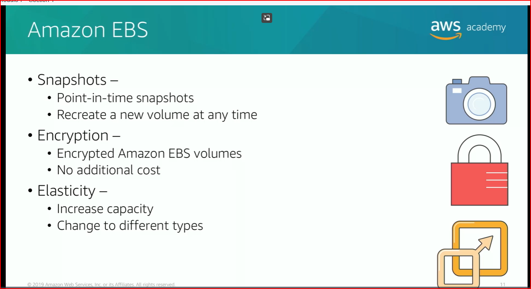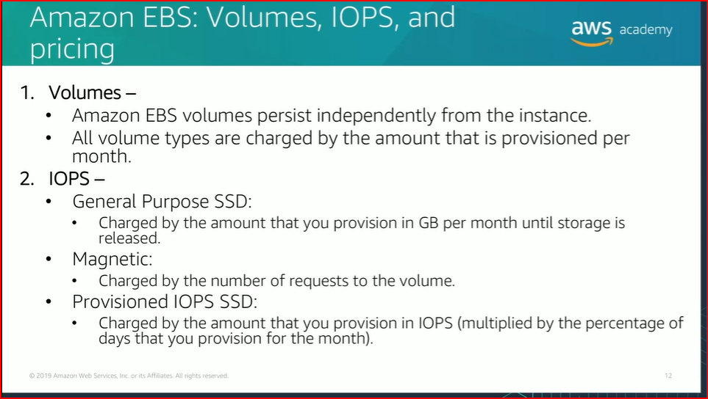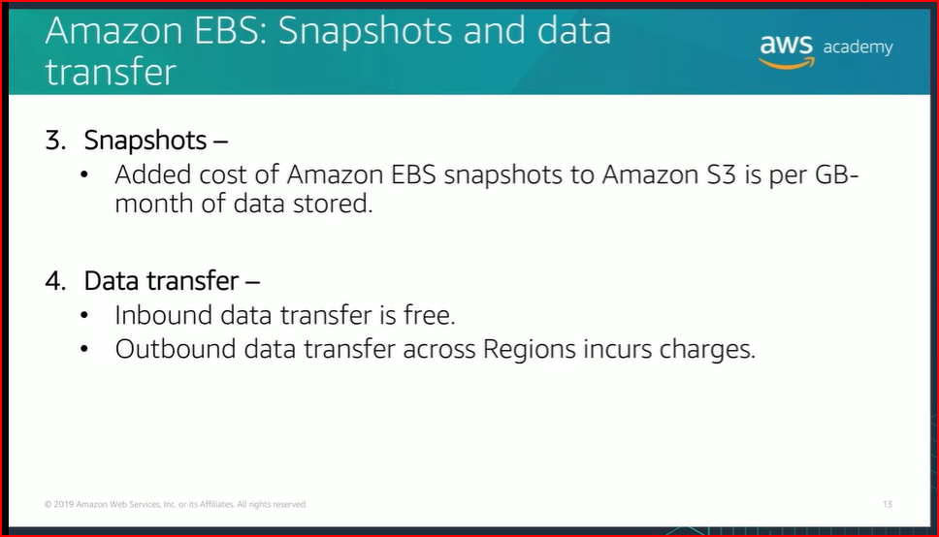

**Module 7-Section 2 Video – AWS S3**

-Data is stored as objects in buckets.

-Virtually unlimited storage.

. Single object is limited to 5 TB.

-Designed for 11 9s of durability.

-Granular access to bucket and objects. 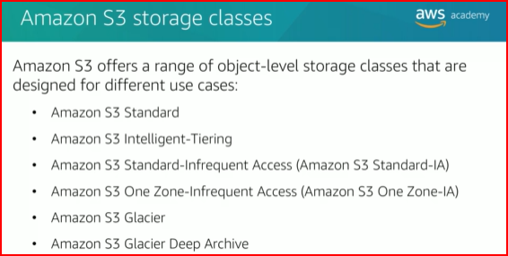

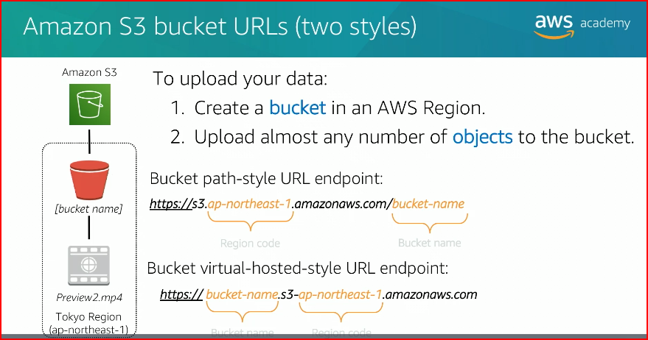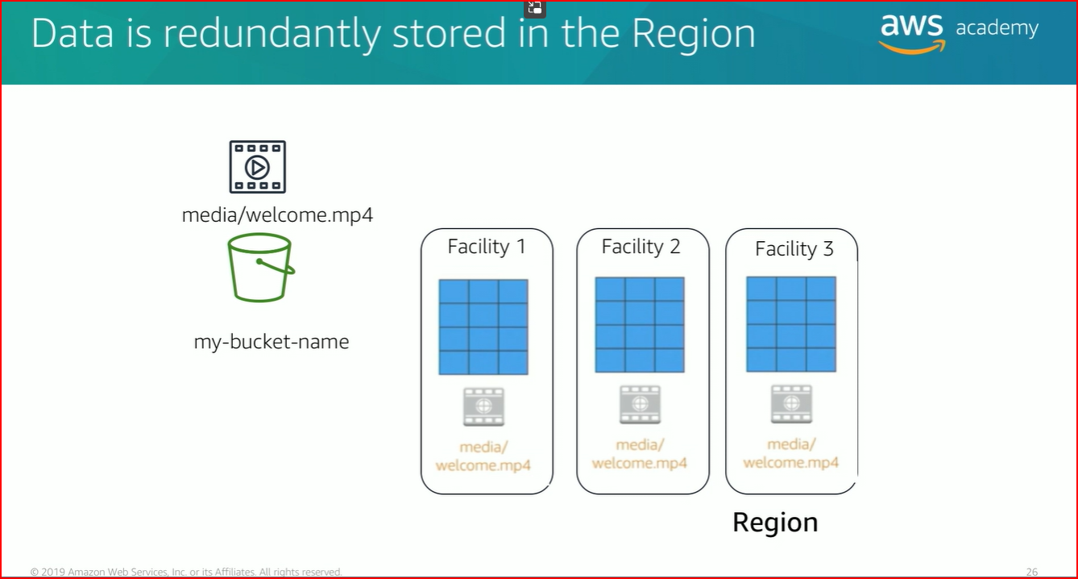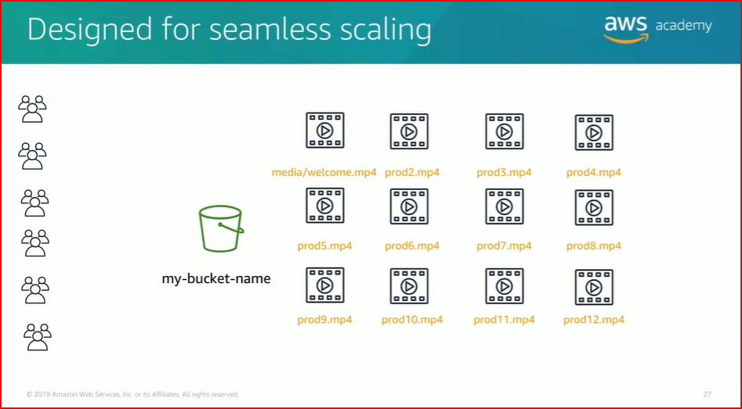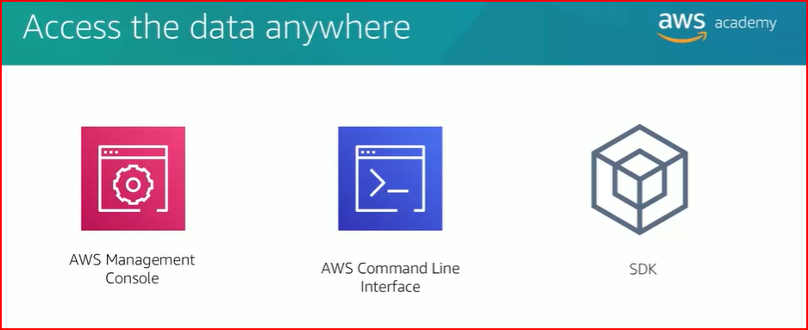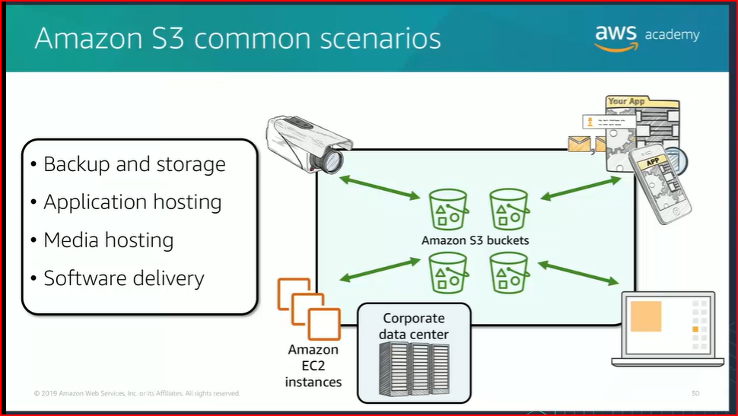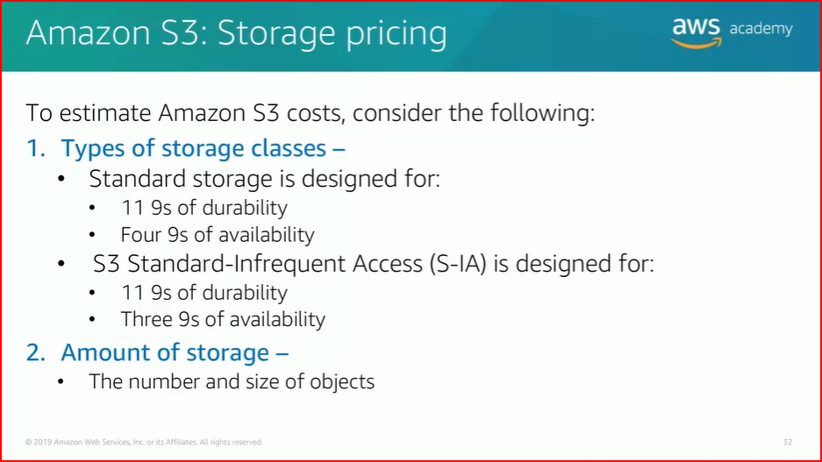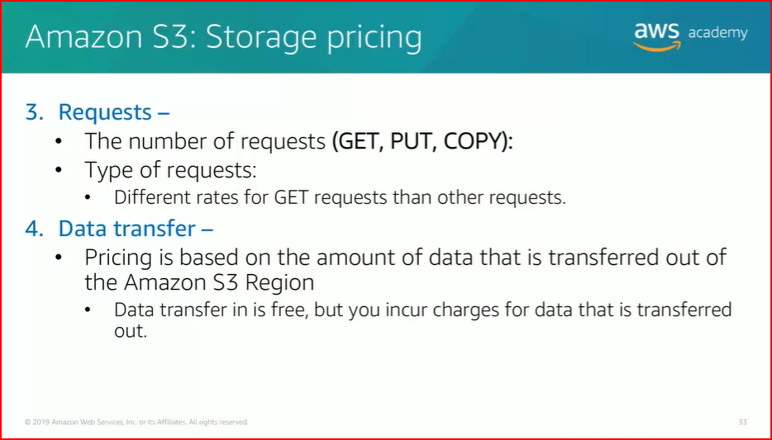

Topic 3: Introduction to MapReduce concepts

Quiz: Check your understanding 2

What do you always have to specify for a MapReduce job?

Answer: The classes for the mapper and reducer

How many times will a combiner be executed?

Answer: Zero, one or many times.

Key/value pair is an important concept in MapReduce; think of it as a phone book, each phone number (key) is linked to a person’s name (value). Which of the following are features of key/value pair? (Choose two.)

Answer(s):

-Keys must be unique, but not values

-A value must have a key, but a key may not have a value.